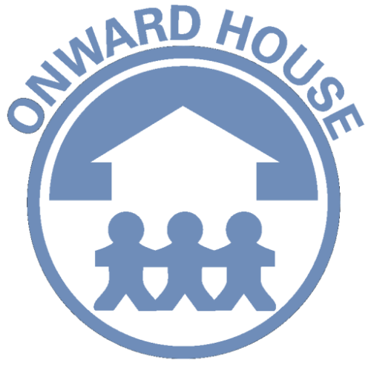

Partnership Support Worker – Job Description

Onward Neighborhood House is rooted in a rich history of social services to improve lives and uplift communities through educational, economic and support services.

As a not for profit, our strength is our ability to adapt to societal change. In the early 20th century, people in the Belmont Cragin (5423 W. Diversey Avenue, Chicago, IL 60639) community needed food, clothing, and shelter – and Onward House responded.

It is the policy of Onward Neighborhood House to provide equal employment opportunity, without regard to race, color, creed, religion, age, sex, national origin, ancestry, mental or physical disabilities, marital status, affectional preference, Vietnam era veteran status, or any other legally protected status.
What you will be doing…
We looking to hire a Partnership Support Worker whose primary responsibilities are to support the center director with monitoring and ensuring Head Start requirements while developing mutually trusting relationships and act as an advocate for families, and provides support services as needed. The Partnership Support Worker will assist families in determining their needs and in identifying and developing goals to meet those needs.

Responsibilities:
- Works with the Program Director to ensure the integration of program components and implementation of Head Start guidelines;

- Provide support to site director in identifying allowable expenses and turning in vouchers on time;

- Participate in reviewing and revising site policies and procedures to ensure compliance with requirements of funding sources and licensing standards;

- Establish strong, trusting and collaborative relationships with participant families and serve as the liaison between parent groups and Program Director and other staff.

- Assist in identifying, planning and conducting Parent Committee Meetings, parent trainings, and parent workshops.

- Responsible for the recruitment and enrollment of eligible children and maintaining all records for enrollment, health, social service and disabilities;

- Provide case management services to families in the Head Start program, including direct services to families by assisting them in determining family strengths, needs and goals.

- Provide resources, referrals and support based on the individual needs of the families.

- Attend Individual Education Plan (IEP) meetings and IFSP meetings to serve as a support and advocate for children and parents.

- Coordinate parent engagement activities through recruitment and organization of events and services.

- Conduct home visits to families at least annually for each family and as needed.

- Perform administrative record keeping and other functions as assigned. Submit all agency reports in a timely manner;

- Collaborate with other staff, volunteers, interns, and/or neighborhood organizations with on-going program implementation and in developing special events.
Competitive Pay Plus Great Benefits:
- Fringe Benefits Include: Paid Vacation, Health and Dental Insurance and Retirement Plan (after 1 year the organization contributes 5% of your pay rate into this plan on your behalf).
The physical demands described below are representative of those that must be met by an employee to successfully perform the essential functions of this job.
This position requires the employee to:
- Regularly lift up to and carry 50 lbs.
- Regularly bend, stoop and kneel and occasionally assists with manual task or projects
- Regularly transport self to different sites and meeting places
- Have manual dexterity and ability to use tools and/or controls as needed
- Have full vision capabilities—including close vision, distance vision and the ability to adjust focus

The work environment characteristics described above are representative of those an employee encounters while performing the essential functions of this job. Reasonable accommodations may be made to enable individuals with disabilities to perform the essential functions.

QUALIFICATIONS:
      - Bachelor’s degree in social work, Human services, family services, counseling or related field required and a minimum of one year experience.
      - Gateways Level 5 Family Services Credential
      - Excellent computer and data entry skills.
      - Excellent organizational, communication, writing and interpersonal skills
      - Valid driver’s license
      - Flexible in work schedule.

How To Apply: Via our website at: onwardhouse.org/careers/ OR Please send Resume to / Envíe su Currículum a Zitlali (Tali) Farias / HR Generalist Email: zfarias@onwardhouse.org

