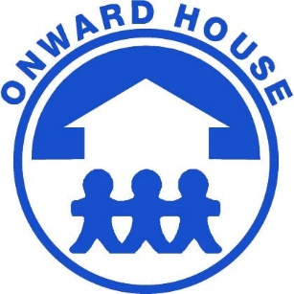

School Age Teacher – Job Description

Onward Neighborhood House is rooted in a rich history of social services to improve lives and uplift communities through educational, economic and support services.

As a not for profit, our strength is our ability to adapt to societal change. In the early 20th century, people in the Belmont Cragin (5423 W. Diversey Avenue, Chicago, IL 60639) community needed food, clothing, and shelter – and Onward House responded.

It is the policy of Onward Neighborhood House to provide equal employment opportunity, without regard to race, color, creed, religion, age, sex, national origin, ancestry, mental or physical disabilities, marital status, affectional preference, Vietnam era veteran status, or any other legally protected status.

What you will be doing…
We are looking for a School Age Teacher. The School Age Teacher is responsible for developing and implementing an enriching academic after-school and summer program for children.

Responsibilities:
- Maintain program policies and procedures consistent with the agency’s mission, and which meet the requirements of funding sources and DCFS licensing standards.

- Create and maintain a safe environment which promotes the safety, trust, respect and security for children, staff and parents.

- Maintain a clean and organized classroom environment by teaching children the importance of taking care of their environment.

- Provide an overall classroom environment that is reflective of multi-ethnic populations, is conducive to enjoyment, relaxation and socialization and has well defined interest areas.

- Promote recognition, acceptance and positive interactions among children and among staff.

- Utilize appropriate child development practices regarding guidance and discipline.

- Demonstrate, instruct, and participate in activities and outputs that result in the achievement of program outcomes as outlined in the Program Outcome Plan.

- Conduct at least two parent teacher conferences annually.

- Maintain records of permission and consents, authorization forms, child observations, anecdotal notes and education files. Consult with supervisor when needed.

- Prepare children and transition plans for children transitioning to another classroom or out of the program.

- Responsible, during the school year, for picking up program children from local public schools and escorting them to Onward Neighborhood House.

- Responsible for scheduling and planning educational field trips and completing the necessary paperwork;

- Responsible for assisting in other classrooms or programs as required by the agency.

MUST HAVE
- Minimum AA/AS degree with (6) semester hours/ (9) quarter hours in early childhood education/child development or elementary education.
- A minimum of one-year experience with school age children under qualified supervision required; two to three years preferred.
- Bilingual (English/Spanish) preferred.
- Flexibility required
Competitive Pay Plus Great Benefits:
- Fringe Benefits Include: Paid Vacation, Health and Dental Insurance and Retirement Plan (after 1 year the organization contributes 5% of your pay rate into this plan on your behalf).
How To Apply: Via our website at: onwardhouse.org/careers/ OR Please send Resume to / Envíe su Currículum a Zitlali (Tali) Farias / HR Generalist Email: zfarias@onwardhouse.org

